**Name: Varshitha**

**USN:4AL17CS106**

Schema and E-R Diagram

1. Consider the following relations:

Student (snum: integer, sname: string, major: string, level: string,age: integer) Class (name: string, meets at: string, room: string, d: integer)

Enrolled (snum: integer, cname: string)

Faculty (fid: integer, fname: string, deptid: integer)

The meaning of these relations is straightforward; for example,

Enrolled has one record per student-class pair such that the student

is enrolled in the class. Level is a two character code with 4 different values (example: Junior: JR etc)

Schema Diagram:

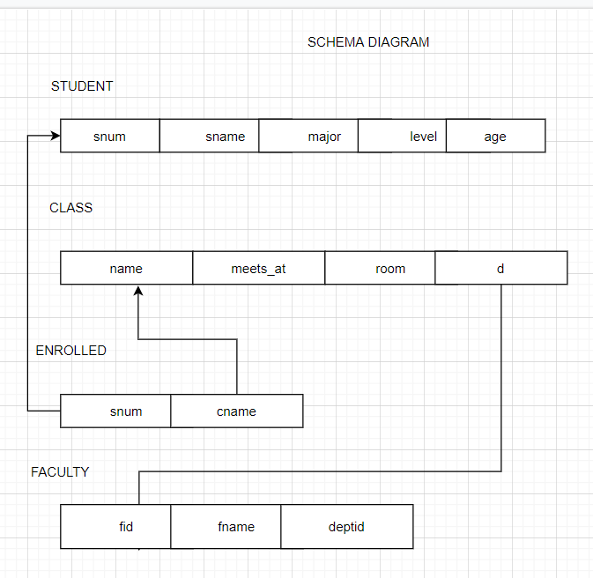

E-R Diagram:

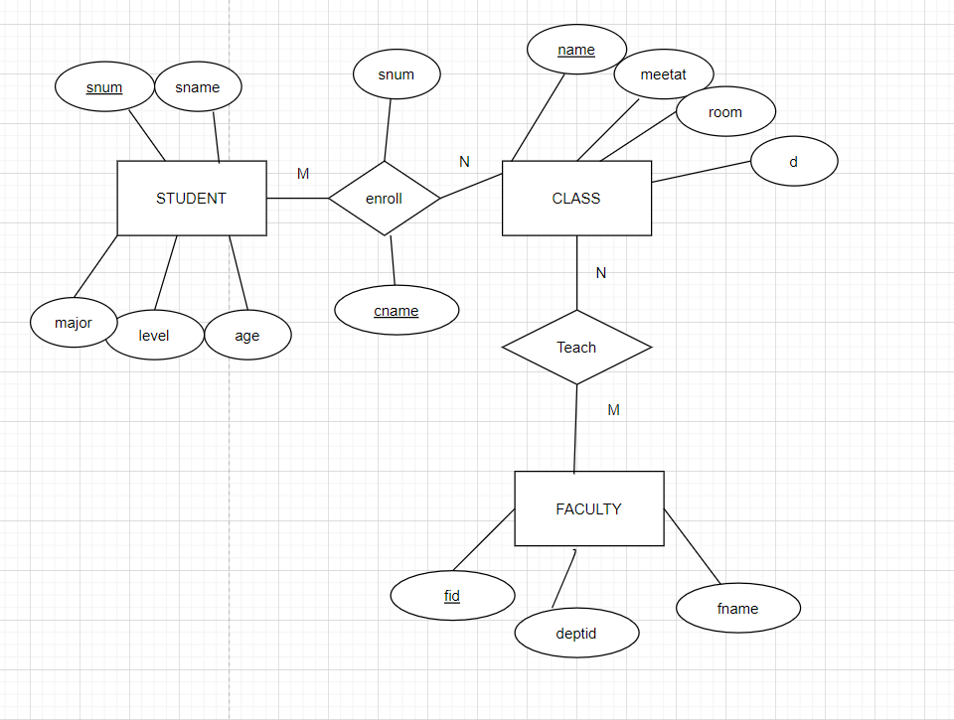

1. Consider the following database for a banking enterprise BRANCH(branch-name:string,branch-city:string,assets:real) ACCOUNT(accno:int,branch-name:string,balance:real) DEPOSITOR(customer-name:string,accno:int) CUSTOMER(customer-name:string,customer-street:string,city:string) LOAN(loan-number:int,branch-name:string,loan-number-int) BORROWER(customer-name:string,customer-street:string,city:string)

Schema Diagram:

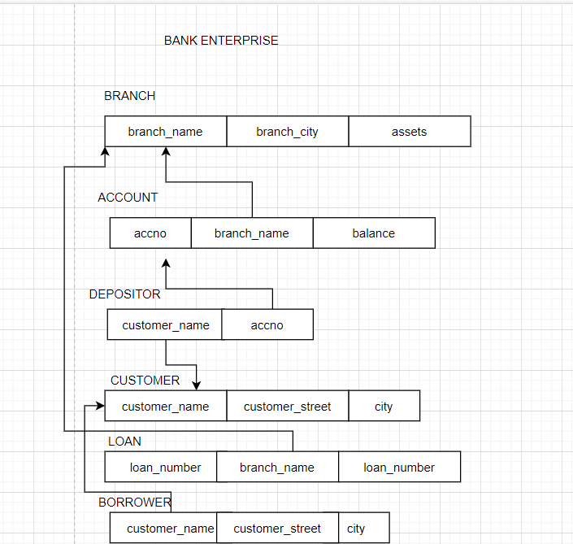

E-R Diagram:

